
Maintenance Rodeo Rules General Guidelines
- Refer to Appendix A – Planning document for list of supplies and other suggested planning details.
- The regional and state rodeo will consist of seven events: Truck & Trailer Competition, Zero Turn Mower Obstacle Course, Backhoe Competition, Blower Competition, Irrigation Assembly, Nail Driving Competition, and Plant Identification.
- The host agency will communicate two months prior to the event any specifics that deviate from the standard equipment specifications. Ie, type and size of Truck/Trailer, hammer size, backpack blower surface or z-mower size. It is preferred that this information is part of the registration form.
- The Truck and Trailer Competition and Irrigation Assembly will consist of two-person teams, the rest of the events are individual contests. * Note an individual can represent their Agency on only one Truck and Trailer team and/or Irrigation Assembly team.

- An individual may only compete in 2 events. The individual may be listed as a sub for a 3rd, however, they may only compete in 2 events. It is up to the discretion of the team leader to determine what 2 events the individual actually participates in.

- An agency may have more than one team compete at a maintenance rodeo event. Individuals who are registered and compete on one team can only compete for that team. (Example: Park Person is signed up to compete in events for AGENCY TEAM 1. Therefore, Park Person cannot compete for AGENCY TEAM 2 or AGENCY TEAM 3 under any circumstances.) All teams will compete against each other.
- Strict adherence to safety is a must and any contestant that engages in dangerous operation of a piece of equipment, horseplay, abusive or distracting language during an event can and will result in disqualification from the competition and all points forfeited. Each of the judges overseeing the equipment events will have whistles that will be used to control the events and maintain safety. All contestants upon hearing a whistle will be required to immediately stop the operation of the equipment and await instruction from the judges. Persons watching the events are asked to adhere to the same safety guidelines outlined in these rules.

- The top 5 contestants or teams (irrigation and truck and trailer) per event in each region, the 1st, 2nd, 3rd, 4th and 5th place winners, are eligible to compete in the state rodeo.
*Note - an agency may have multiple participants from multiple teams at the state rodeo provided they qualify at their regional rodeo. These participants will compete at state on the same agency team that they competed for at the regional.

- The Regional & State Rodeo will be scored as follows: 5 points for first place, 4 points for second place, 3 points for third place, 2 points for fourth place and 1 point for fifth place. Awards will be given for the first three places and certificates to 4th and 5th place.

  - Reminder - Irrigation and Truck and Trailer have two contestants for each team and they should each receive an award for 1st, 2nd, and 3rd and certificates for 4th and 5th.

- The team that accrues the most points during the competition will be declared the Regional or State Champion. An award will be given to the agency that wins 1st place. If an Agency has multiple teams competing in the regional or state rodeo, each team’s points must remain separate and cannot be combined for overall standings. An agency cannot combine winning individuals from multiple regional teams in order to make one “All Star” State team. Ie, If Bingville competes at the Regional and has Team West and Team East and Bob on Team East takes 1st place in Truck and Trailer and Joel on Team West takes 1st in Nail Driving – They still represent those specific teams at State. They cannot be combined into one team for State.

- It is the responsibility of the head organizer of the Maintenance rodeo, and the Regional POPS Branch chair to verify that all rodeo results and scores were judged fairly and scored accurately prior to those results being announced to the participants. At the State Maintenance Rodeo, the State POPS branch chair will also verify all scores prior to being announced to the participants.

- If at the end of the competition a tie exists between teams during the Regional or State Rodeo, a tie breaker will be held to determine the winner. The winner will be determined by adding the total of each team’s 1st and 2nd place wins in events together. The team with the most points will be considered the winner. If there is still a tie, the 3rd place wins will be taken into account.

Revised by Joey Gomez, Giovanni Ortiz, Jason Hagen, Johann Ortiz 8/7/26

Example Tie Breaker
Team | Truck and Trailer | Irrigation | Weed and Plant | Nail Drive | Backhoe | Zero Turn | Back pack blower | Total
Big City - West | 3 | 1 | 3 |  |  | 2 | 5 | 14
West Canaan |  | 2 |  | 3 | 5 | 1 | 4 | 15
Pinetown | 5 |  | 5 | 4 | 3 | 4 | 1 | 22
Big City - South |  | 4 | 1 |  | 4 |  |  | 9
Big City - Central | 4 | 5 |  | 5 | 2 | 3 | 3 | 22
Bingville  - West | 2 |  | 4 | 1 | 1 | 5 |  | 13
Bingville  - East | 1 | 3 | 2 | 2 |  |  | 2 | 10

Pinetown and Big City - Central have tied in points with 22. Therefore, we would add each team’s first place and second place finishes to determine the winner
- Pinetown : 5+5+4+4 = 18
- Big City Central : 5+5+4 = 14
Based on the totals, Pinetown would be declared the winner of the rodeo. Big City – Central would be the 2nd place team. Cities with more than 1 team cannot combine their team scores for the overall standings. While Bingville - East and Bingville – West are from the same Agency; they cannot combine their points. Same goes for all the Big City teams. Which is why Big City– Central was still in a tie and did not win out right. It is the individual team that is declared the winner.

Regional Specific
- The regional rodeo consists of seven events: Truck & Trailer Competition, Zero Turn Mower Obstacle Course, Backhoe Competition, Blower Competition, Irrigation Assembly, Nail Driving Competition, and Plant Identification. Additional “recreational” events may be added by the host agency for the purposes of entertainment. However, only the seven events listed above will count towards overall standings.

- The top 5 contestants or teams per event in each region, the 1st, 2nd, 3rd, 4th and 5th place winners, are eligible to compete in the state rodeo. *Note an agency may have multiple participants entered at the state rodeo provided they qualify at their regional rodeo.

- Each region shall send the name of the 6th place winner in each event as an alternate. In the event that 1st, 2nd, 3rd, 4th and 5th place winners from a region cannot participate or do not register for the state rodeo. The regional alternate will be invited by their region’s Director to represent their region at the state rodeo.

- An agency may have more than one team compete at a maintenance rodeo event. There may be a limit on the number of teams an Agency may have. This is at the discretion of the Regional TRAPS Director and Regional POPs Branch representative and is subject to time constraints and resources. Individuals who are registered and compete on one team can only compete for that team. (Example: Park Person is signed up to compete in events for AGENCY TEAM 1. Therefore, Park Person cannot compete for AGENCY TEAM 2 or AGENCY TEAM 3 under any circumstances.)

- Regional rodeo results will be verified prior to the scores being announced to the participants. Regional rodeo organizer from the host agency and the Regional POPS branch chair are responsible for making sure that events have been judged fairly and scored correctly. Results must be approved prior to being announced to the participants.
- Regional rodeo results shall be submitted to the TRAPS office by the regional rodeo host cities within one week of the event. Regional directors shall verify the results for their region’s rodeo have been submitted to TRAPS (TRAPS will send all regional results to the Institute and Expo host agency and the POPS Chair so they can verify registration for the state rodeo as registrations are submitted.

State Specific
- The state rodeo will consist of seven events: Truck & Trailer Competition, Zero Turn Mower Obstacle Course, Backhoe Competition, Blower Competition, Irrigation Assembly, Nail Driving Competition, and Plant Identification. Additional “recreational” events may be added by the host agency for the purposes of entertainment. However, only the seven events listed above will count towards overall standings.
- For TRUCK & TRAILER and IRRIGATION COMPETITION ONLY: If an event team qualifies for state rodeo but one of the members cannot attend the state rodeo; a substitute may attend in the missing team member’s place. However, the substitute must be the same substitute that was listed on the original regional form for the state qualifying team. No other individuals will be allowed to compete as the substitute. 2 different teams from the same agency may not be combined.
- An agency may have more than one team compete at the state maintenance rodeo event, but the team members must compete as the team name they competed under at the Regional level. (Example: Park Person is qualified for state and competed in the regional rodeo under AGENCY TEAM 1. Anyone on AGENCY TEAM 1 that qualified at the Regional can compete together at State as AGENCY TEAM 1. However, if someone from AGENCY TEAM 2 also qualified, they cannot combine with TEAM 1 from their agency. They will be competing at State as a separate team. This is to level the playing field for agencies of different sizes.) It is the responsibility of the rodeo host and POPS branch chair to ensure that if an Agency with multiple teams competes then they are scored as separate teams.
- The team that accrues the most points during the competition will be declared the State Champion. If an Agency has multiple teams competing in the regional or state rodeo, each team’s points must remain separate and cannot be combined for overall standings.

Truck / Trailer Course Rules
- The host agency will communicate at least two months prior to the event the specific size of the equipment used. Truck size and wheelbase length, trailer size, hitch length, and course size used.
- This event consists of a team of two people; a driver and a backup guide.
- The course setup consists of one truck/trailer and trailer stall (see attached layout diagram).
- One half-ton truck (preferably single cab) and one 7-foot wide by 16-foot long (Cargo area) tandem axle trailer will be used. If these specifications are not available, then other size trucks/trailers can be used but the course will need to be modified to meet the change in sizes.
- The object is to
  - Remove wheel chocks and put them on the trailer. Chocks are only required on one side of the trailer.
  - Pull out and complete the figure eight course and back the truck and trailer back into the original start position and chock the wheels.
- Challenges - The object of the tennis ball is to force the contestants to operate the vehicle in a very careful and deliberate manner to maximize safety even though this is a timed event. Penalties will be assessed for each tennis ball knocked from its perch.
  - Thirteen cones will be placed along the sides and back of the stall exactly 6 inches from the widest point of the trailer (typically the fender wells) with a tennis ball balanced on top (see attached detail).
  - A traffic cone will be placed in the center of the trailer with a tennis ball balanced on top.
  - For course safety, the judges will not attempt to reset any tennis balls that are knocked off during a run. Judges will monitor the cone for further contact and assess penalties as needed. The course will be reset before the next contestant starts.
  - Contestants will not be penalized if portions of the truck/trailer extend beyond the outer cone perimeter while following the course; however, you will be disqualified if more than one tire leaves the course.
- Procedure: Seat belts must be used at all times when the vehicle is in motion, failure to do so will result in disqualification.
  - Guide
    - When the whistle blows to start the event, the guide must remove their seat belt, exit the truck, remove the wheel chocks, put them on the trailer, get in the truck, fasten their seat belt and remain in the truck until the driver has come to a complete stop and is ready to begin backing up into the stall. The guide’s seatbelt must be fastened before the vehicle is put in Drive.
    - The backup guide will be allowed out of the truck only when the truck and trailer is within 8 feet of the stall (there will be an indicator stripe 8 feet in front of the stall for this purpose). The vehicle must come to a complete stop before the guide removes their seatbelt and opens the door. Once the guide closes the door and is clear of the truck then the driver can resume moving.
    - When the guide signals to the driver to stop in the stall, and the vehicle is put in Park, the guide shall replace the wheel chocks and raise their hands to complete the run.
    - The guide is not allowed to cross between the truck and trailer. Doing so will result in disqualification.
  - Driver
    - The driver must stay in the vehicle at all times.
    - The truck and trailer must be backed into the stall to a depth in which the front bumper of the truck clears the base of the front cone. This will leave the rear of the trailer 2 feet from the rear of the cone.

    - The driver can then choose to go for the bonus points by attempting to pull within 6 inches of the rear cone without touching it. The Guide is allowed to signal to the Driver in order to assist with the bonus attempt.

    - Driver must remain seat belted and with his or her hands off the steering wheel and shifter until the guide is in the vehicle and seat belted. Only then will the driver be allowed to put their hands on the steering wheel, put the truck in motion, and navigate the course.

- Timing

- Time starts when the judge blows the whistle and ends when the truck and trailer are returned to the starting position, the transmission is placed in park, the engine is turned off, the wheels are chocked, and the guide raises their hands.
- Time limit for this event is 3 minutes.

SCORING
- Total time from start to finish in seconds.
- For a bonus subtract 30 seconds for a perfect run in which no tennis balls were knocked off, also subtract 30 seconds for getting the trailer within 6” of the back stanchion without touching it.
- Add any penalty time to determine a final adjusted time score.
- Team with the lowest final time is the winner.
- Results should be scored through 6th place for the Regional event to determine an alternate if needed for State.
PENALTIES
- Add 30-second penalty for each tennis ball knocked off a stall stanchion.
- Add 30-second penalty for not putting the chocks on the trailer
- Add 60-second penalty for knocking off trailer tennis ball.
- Disqualification for spinning tires on truck. Judges may suspend this rule depending on course surface. This decision must be made prior to the event.
- Disqualification for not wearing seatbelt when vehicle is in motion.
- Disqualification for guide going between truck and trailer.
- Disqualification for moving the truck while the Guide is entering or exiting the truck. The door must be completely shut before the truck can move.
- Disqualification if more than one tire leaves the course.

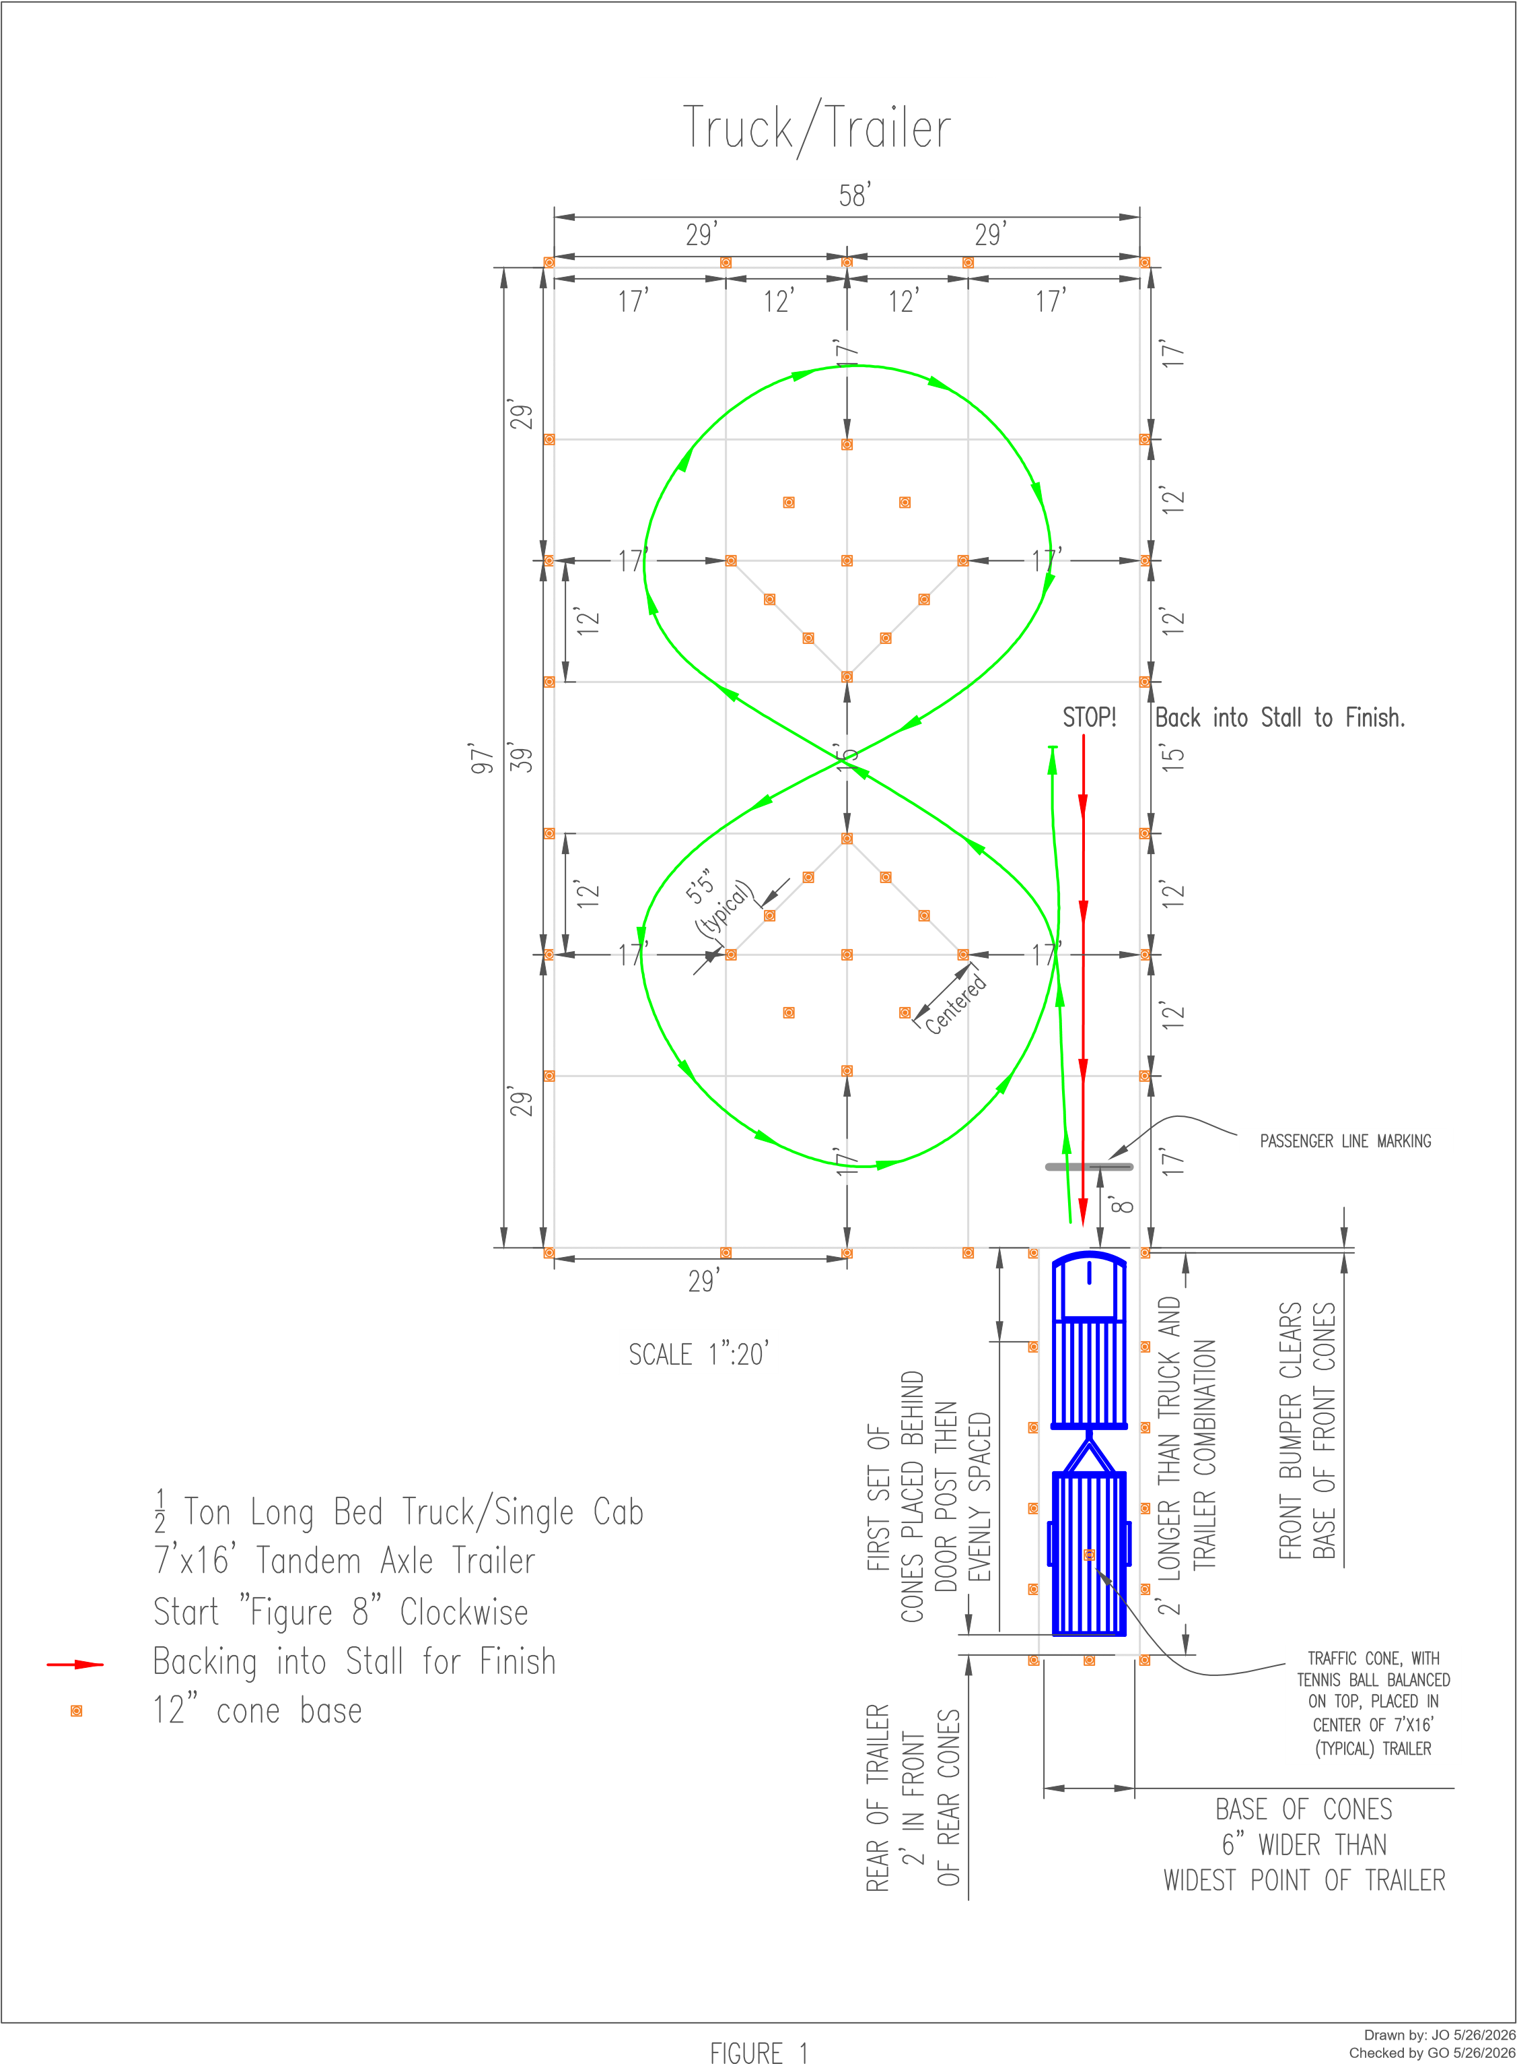
JUDGE’S SCORING FORM

TRUCK & TRAILER COURSE
Contestant 1:
Contestant 2: Agency/Team: Time Limit: 3 minutes
Elapsed time: : : Elapsed time converted into seconds:

Penalties
- Add 30 second penalty for each tennis ball knocked off a stall stanchion or cone.
- Add 60 second penalty for knocking off trailer tennis ball.
- DQ for spinning tires on truck.
- DQ for not wearing seatbelt when vehicle is in motion.
- DQ for guide going between truck and trailer.
- DQ for moving the truck while the Guide is entering or exiting the truck. The door must be completely shut before the truck can move.
- DQ if more than one tire leaves the course.
- Number 30 second penalties: (i.e. 3 penalties = 90 seconds) Number 60 second penalties: (i.e. 4 penalties = 240 seconds)
Disqualification? Yes No

Scoring
- Subtract 30 seconds for a perfect run in which no tennis balls were knocked off.
- Subtract 30 seconds for getting the trailer within 6” of the back stanchion without touching it.
Elapsed time (in seconds)
+ total penalties (in seconds)
- bonus (in seconds)
Final time (in seconds)
Ranking: (Completed after all contestants have gone.)Judge’s Signature
Judge’s Signature

Zero Turn Mower Obstacle Course Rules
- The course will be set up for a zero-turn radius under-belly mower. The mower is not brand specific and should be no smaller than 60” but not to exceed a 72” deck.
- All contestants must use the same mower unless circumstances, such as damage or needed repair, call for the use of a second zero-turn mower. If a second mower is to be used; it must be the exact same brand and deck size as the original.
- The object is to:
  - Follow the directions given in the attached diagram, circling the obstacles to the operator’s left on the way down to the picnic table which is to be circled clockwise and circling the obstacles to the operator’s right on the return.
  - Individuals must complete the course by memory. At no time will arrows be placed or painted on the course to give directions.
  - Conclude by pulling headfirst into the parking stall so that the rear tires go past the designated line and then backing out and returning the vehicle to the start position.
- Seat belts must be used at all times when the vehicle is in motion, failure to do so will result in disqualification.
- Challenges
  - Tennis balls will be placed on top of the cones to help judges determine when the contestant has struck a cone.
  - For course safety, the judges will not attempt to reset any tennis balls that are knocked off during a run. Judges will monitor the cone for further contact and assess penalties as needed. The course will be reset before the next contestant starts.
  - The cones on the outside perimeter of the course are considered “out of bounds indicators” and a 30 second penalty will be assessed for every ball knocked off.
  - The cones on the four corners of the picnic table will be considered “contact indicators” and a 60 second penalty will be assessed for every ball knocked off.
  - A ball will also be placed on top of a 1” PVC coupler on top of the picnic table. If this ball falls off the coupler, that will indicate that the contestant has “run over” the picnic table and he/she will be disqualified. (A flat board may be placed on the table top if a smooth surface is needed for the coupler)
  - 55 Gallon drums will be placed in the center of the course. Tennis balls will be placed on a 1” PVC coupler on top of each barrel to serve as “contact” indicators. If a tennis ball is knocked off a PVC coupler, it will count as a 60 second penalty.
  - Dimensions for the obstacles will be 5” per side wider than the widest point of the mower used. Spacing between cones will be 10” wider than the widest point of the mower. Spacing between cones is measured inside to inside of the base of the cones. The diagram has estimated widths and should be used as a template to layout the course. The actual spacing may be different than what is on the map depending on the size of mower that is used.
  - No practice or warm-up.
  - The table will be 6’ long.
- Timing
- Time will start at the whistle and will end when the operator sets the parking brake and turns the machine off. Before the whistle is blown for the start, the operator will

start the mower, buckle seat belt. Hands must be off the control arms and the control arms must be extended out in the neutral position. Once the start whistle is blown then the operator can disengage the parking brake.
  - Time limit for this event is 3 minutes.

SCORING
- Total elapsed time from start to finish in seconds.
- For a bonus, subtract 30 seconds for a perfect run in which no cones or obstacles are hit; add any penalty time to determine the final adjusted time score.
- The person with the fastest final time is the winner.
- Results should be scored through 6th place for the Regional event to determine an alternate if needed for State.

PENALTIES
- Add a 30-second penalty for each tennis ball knocked off an “out of bounds” cone.
- Add a 60-second penalty for “contacting” an obstacle.
- Disqualification for not following the prescribed course in the directions indicated.
- Disqualification for running over cones or obstacles. This will be determined by knocking the ball off the can on the picnic table, knocking over a 55-gallon drum, or knocking over or driving over a cone.
- Disqualification for not wearing a seatbelt.

JUDGE’S SCORING FORM

ZERO TURN MOWER OBSTACLE COURSE
Contestant: Agency/Team: Time Limit: 3 minutes
Elapsed time: : : Elapsed time converted into seconds:

Penalties
  - Add 30 second penalty for each tennis ball knocked off an “out of bounds” cone.
  - Add 60 second penalty for “contacting” an obstacle.
  - DQ for not following prescribed course in the directions indicated.
  - DQ for running over cones or obstacles. This will be determined by knocking the ball off the can on the picnic table, knocking over the 55 gallon drum, or knocking over or driving over a cone.
  - DQ for not wearing seatbelt.

# 30 second penalties: (i.e. 3 penalties = 90 seconds) # 60 second penalties: (i.e. 2 penalties = 120 seconds) Disqualification? Yes No

Scoring
  - Subtract 30 seconds for a perfect run in which no cones or obstacles are hit.

Elapsed time (in seconds)
+ total penalties (in seconds)
- bonus (in seconds)
Final time (in seconds)
Ranking: (Completed after all contestants have gone.)
Judge’s Signature Judge’s Signature

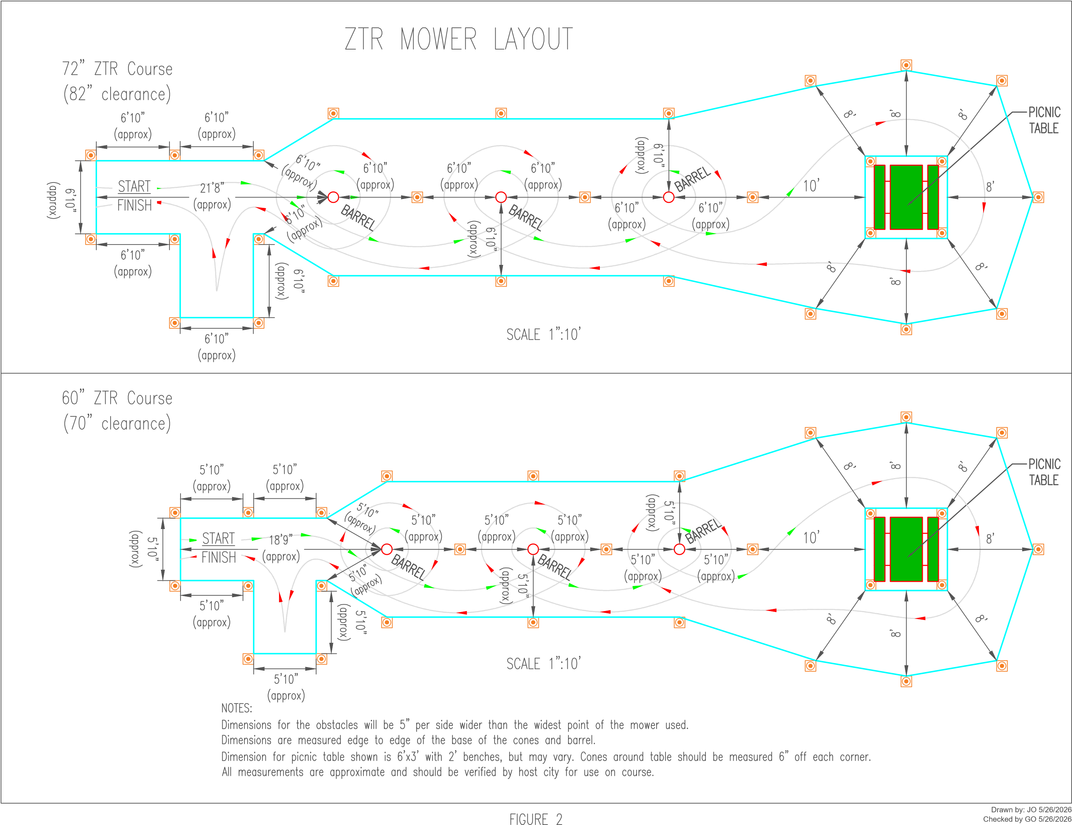

Backhoe Competition Rules
The host agency will communicate at least two months prior to the event the type of backhoe to be used. To include make/model, size, bucket type, and type of controls.
For safety purposes, A radius line is to be clearly drawn 3’ beyond the reach of the backhoe bucket. A judge, finding any contestant or team member inside that line before or during the event when the backhoe is running, will disqualify that team from the backhoe event.

The contest will consist of picking up three kettlebells, a 10 #, 20 # and 30 #, and attempting to place each one inside a color coded circle that matches the kettlebell and returning the bucket back to the starting point.

The three kettlebells shall be placed in the front of the backhoe on a 4’x8’ piece of plywood with the three color coded circles in a starting position. The three kettlebells on the plywood should be located so the tractor can easily pick up each kettlebell. The backhoe bucket shall be fully curled in and the boom in the upright position (normal position for transport) with stabilizers extended to lift the front tires slightly off the ground and the front blade level and in solid contact with the ground with the parking brake on. A radius line shall be clearly drawn or painted > to 3’ beyond the maximum reach of the backhoe bucket. Two 2’ X 2’ pieces of ¾” ply wood on which the kettlebells are to be placed shall be painted with color coded circles. (The plywood can be larger if needed to allow for a larger circle to match the radius height of the kettlebell) The third circle shall be painted on top of a 55 gallon drum. Circles shall be painted on the plywood and on top of the barrel with a radius 3” longer than the height of the standing kettlebell so that the handle of the kettlebell if centered, yet having fallen over can fit within the diameter of the circle. The corners of the plywood targets and the perimeter of the barrel shall be clearly marked on the ground so they can be relocated in the same position for each contestant.

Each contestant will be allowed to operate the backhoe in a normal fashion (extending, curling and swinging) without touching the kettlebells for one minute to get a feel for the tractor. After returning the backhoe to the start position and both hands are removed from the controls, the judge will blow the whistle and start the time. The contestant will attempt to pick up each kettlebell from the starting position and place them on the color coded target and return the backhoe to the start position. The judge will record the time with a stop watch. Time starts at the whistle and ends when the operator returns the backhoe to the start position and removes his/her hands from the controls.

All three kettlebells must be completely inside the color coded circles in order for the score to count. If any part of any kettlebell is on or over (above) the line the contestant will be disqualified. Time limit for this event is 4 minutes.

SCORING
Total time from start to finish in seconds: Add twenty seconds for any kettlebell that falls over yet remains inside the color coded circle to determine a final adjusted time score. The person with the lowest final time is the winner. Results should be scored through 6th place for the Regional event to determine an alternate if needed for State.

PENALTIES
- Add 20 seconds for any kettlebell that falls over yet remains inside the painted circle.
- Disqualifications for placing any part of a kettlebell outside or above the painted circle.
- Disqualification for any damage to or knocking over the barrel.
- Disqualification for damage to the plywood board or surrounding area.
- Disqualifications for exceeding the four minute time limit.

JUDGE’S SCORING FORM

BACKHOE COMPETITION
Contestant:

Agency/Team:

Time Limit: 4 minutes

Elapsed time: : : Elapsed time converted into seconds:

Penalties
- Add 20 seconds for any kettlebell that falls over yet remains inside the painted circle
- DQ for placing any part of a kettlebell outside or above the painted circle
- DQ for any damage to or knocking over the barrel
- DQ for damage to the plywood board or surrounding area.
- DQ for exceeding the four minute time limit
Number of 20 second penalties: (i.e. 2 penalties = 40 seconds of added time) Disqualification? Yes No

Scoring
Elapsed time (in seconds)
+ total penalties (in seconds)

Final time (in seconds)

Final Ranking: (Completed after all contestants have gone.)
Judge’s Signature

Judge’s Signature

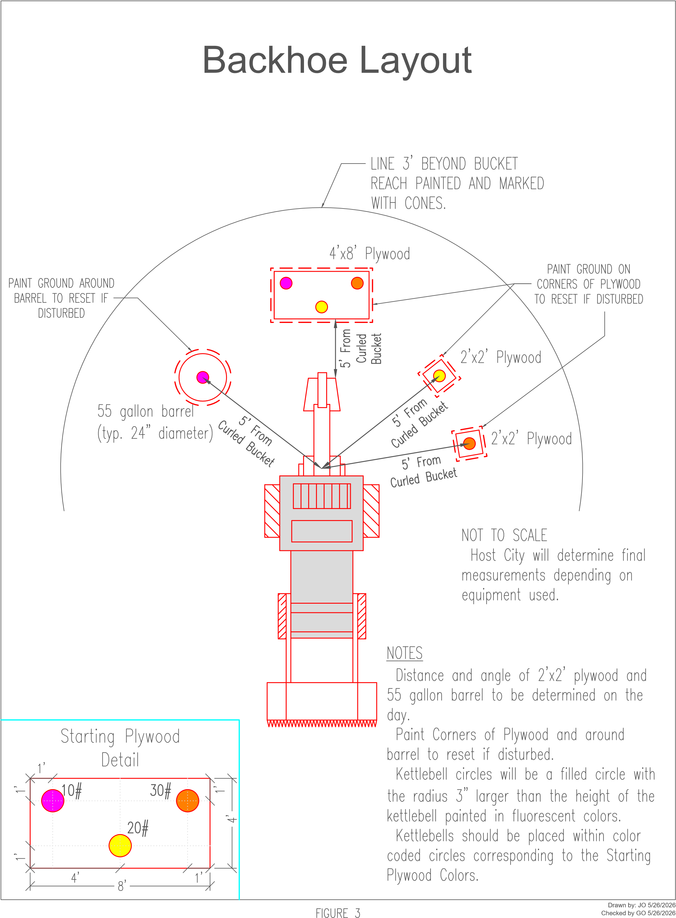

Nail Driving Contest Rules
- The host agency will communicate at least two months prior to the event the size hammer to be used.
- A 24-ounce framing hammer between 14” and 16” length will be used to drive a 20d 4” bright common nail into a 4”x6” pine plank.
- A 4”x6” pine plank will be placed on the ground, and one secured on a sawhorse. They will be placed on the 4” side.
- The contestant will have the option to hit the plank on the ground or on the sawhorse.
- The object is to use the fewest number of hits to drive the nail fully into the wood.
- Procedure:
  - Contestants will enter the safety area and don safety equipment provided (face shield).
  - A nail will already be started in the wood at a predetermined depth using a pre-cut jig to maintain consistency. (example – a metal block or pvc tube). The nail will start out aligned straight up and down to prevent possible safety issues. Using the framing hammer, the contestant may strike the nail as many times as necessary to bury the nail to the head into the wood.
- Every touch of the hammer to the nail or wood (in case of a miss) counts as a strike.
- The contestant isn’t allowed to touch the nail with his/her hands to straighten it or otherwise. They may however touch the board.
- The contestant is allowed to kneel if the pine plank for the event is located on the ground.
- A contestant will not be allowed to start over if they bend the nail.
- Only fully driven nails count.
- Practice taps at the beginning count towards the strike count if they touch the nail.

SCORING
- Fewest number of hits required to drive the nail completely into the wood is declared the winner.
- Results should be scored through 6th place for the Regional event to determine an alternate if needed for State
.

PENALTIES
- Disqualification for bending nail to the extent it cannot be driven flush.
- No score for any nail not driven flush to the head. Any nail head that a business card can be slipped under is not flush.

TIE BREAKER
  - In the event of a tie, the individuals who have tied on the number of strikes of the nail during the general event round will compete against each other in a tie breaker.
  - Tied Individuals will repeat the nail driving event again until one individual has clearly driven a nail in the least amount of strokes. In the event of 3 or more individuals who tie for least amount of strikes; this tie breaker process will be utilized to determine the winner of the tie and places thereafter.
  - Points will be distributed accordingly. Please see tie breaker rule example for clarification.

Nail Driving Tie Breaker Example
The Nail Driving Event has taken place and after the general event round, it has been determined that there is a 3 way tie.

Contestant | General Event Round | Tie Breaker  Round 1 | Tie Breaker  Round 2 | Tie Breaker  Round 3 | Final Places
Joe | 3 | 3 |  |  | 2nd
Tim | 4 |  |  |  | 5th
Derek | 2 |  |  |  | 1st
Billy | 3 | 4 | 3 | 3 | 3rd
Hunter | 3 | 4 | 3 | 5 | 4th
Justin | 7 |  |  |  | 7th
Clint | 6 |  |  |  | 6th

- Since Derek has the fewest strikes after the general event round; he is awarded 1st place in the event. Joe, Billy, and Hunter have all tied for 2nd place and will have compete for places 2-4 in the tie breaker. Tim has the next fewest so he will receive 5th place.
- During the first tie breaker round Joe drives the nail in 3 strikes. Billy and Hunter tie again. Joe is awarded 3rd place.
- Billy and Hunter continue competing in tie breaker rounds until Billy finally drives the nail in 3 strikes and Hunter drives it in 5 strikes. Billy is awarded 3rd place in the event and Hunter 4th place.
JUDGE’S SCORING FORM

NAIL DRIVING CONTEST

Contestant: Agency/Team:

Penalties
  - DQ for bending the nail to the extent it cannot be driven flush.
  - No score for any nail not driven flush to the head. Any nail head that a business card can be slipped under is not flush.

Disqualification? Yes No

Scoring
Total # of hits

Ranking: (Completed after all contestants have gone.)

Judge’s Signature Judge’s Signature

NAIL DRIVING TIE BREAKER

- In the event of a tie, the individuals who have tied on the number of strikes of the nail during the general event round will compete against each other in a tie breaker.
- Tied Individuals will repeat the nail driving event again until one individual has clearly driven a nail in the least amount of strokes. In the event of 3 or more individuals who tie for least amount of strikes; this tie breaker process will be utilized to determine the winner of the tie and places thereafter.
- Points will be distributed accordingly. Please see tie breaker rule example for clarification.

Backpack Blower Competition
  - The host agency will communicate at least two months prior to the event the type of surface the course will use. Natural grass is preferred.
  - The object is to:
    - Use air from a backpack blower to force a tennis ball through openings created by wickets or cones in the quickest time.
    - All openings in the wickets or created by cones must be consistent. All openings must be between 12”-16” wide from inside edge to inside edge.
  - Procedure:
    - The participant will begin at the start line and use air to force the ball through the openings along the route indicated on the attached diagram.
    - Ball must pass through the openings in the correct order and direction as indicated.
    - If the ball passes the opening without going through it then the ball must be directed around the opening to pass through the opening in the correct direction. The ball may not pass through the opening in reverse.
  - Equipment
    - The backpack must be worn with both arms through the shoulder harness.
    - Hearing protection must be worn.
    - The standard straight extensions will be placed on the flexible hose and both must remain attached throughout the contest.
    - No additional attachments will be allowed on the hose of the blower other than is provided.
    - It is preferred that metal wickets be used on the course. However, cones may be used if wickets are not available.
    - The course should be painted out on level ground. The preference is grass however; concrete, asphalt, or artificial turf areas may be used.
  - Timing
    - Time starts at the whistle and ends when the ball crosses the finish line.
    - Time limit is three minutes

- Scoring

  - Results should be scored through 6th place for the Regional event to determine an alternate if needed for State.

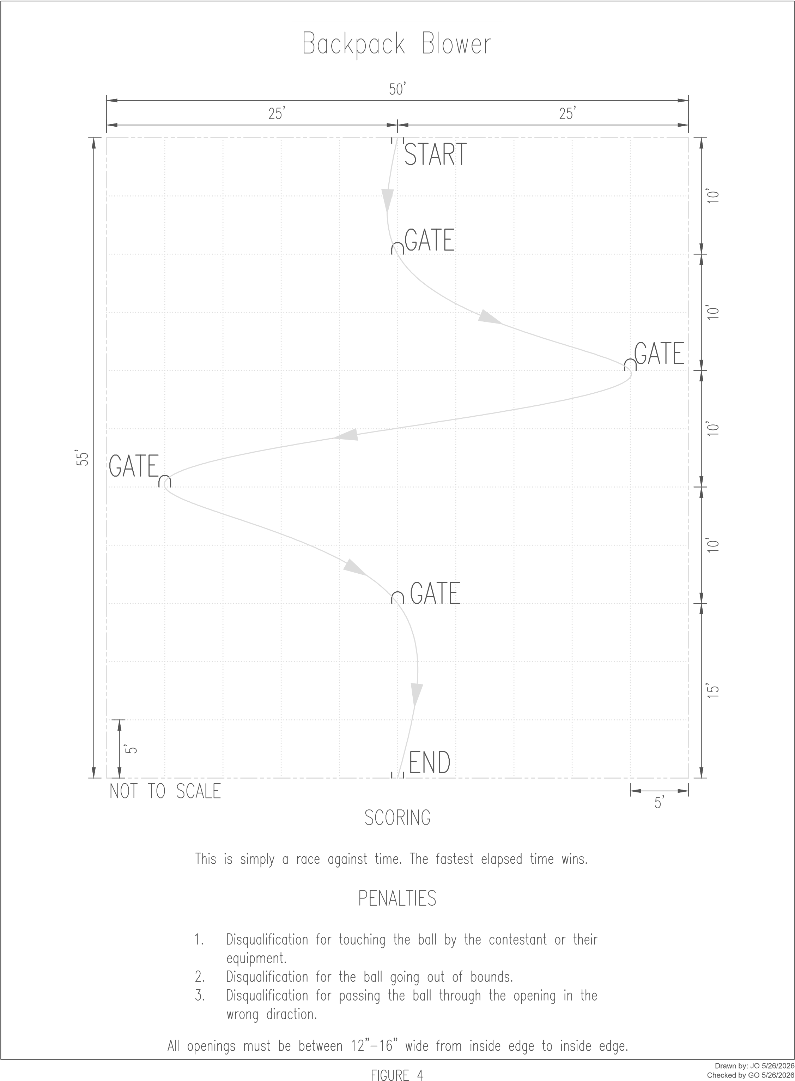
JUDGE’S SCORING FORM

BACKPACK BLOWER COMPETITION
Contestant: Agency/Team:

Time Limit: 3 minutes

Elapsed time: : : Elapsed time converted into seconds:

Penalties
- DQ for touching ball by contestant or equipment.
- DQ for ball going out of bounds.
- DQ for passing the ball through the Opening in the wrong direction.
Disqualification? Yes No

Scoring
Elapsed time (in seconds)

Final time (in seconds)
Ranking: (Completed after all contestants have gone.)
Judge’s Signature

Judge’s Signature

Plant and Weed Identification

RULES
  - To prevent any preview by contestants, plants and weeds will be placed on tables in a secluded area. Every effort should be made to keep others from viewing the testing materials. Contestants that have completed the event should be kept in a separate area from those that are waiting to compete. Phones or books are not allowed until the competition is completely over (in the event a tie-breaker is needed).
  - The object is:
    - To correctly identify a total of 20 plants; 10 ornamentals, 5 trees, 5 weeds. Plants shall only be available in pots and/or cuttings. Pictures are not allowed as a substitution.
  - The following are a list of reference sources for this competition:
    - Know It and Grow It III by Carl E. Whitcomb
    - Weeds of Southern Turfgrasses by the Clemson University Cooperative Extension Service.
    - Landscape Plants of Texas and Environs 3rd Edition by Michael A. Arnold
    - https://wildlife.tamu.edu/know-your-plants/.
    - If the common name for any plant is not listed in the reference materials, it will be marked incorrect. There will be NO exceptions to this rule.
    - An answer key should be completed prior to the event starting so that it can be referenced if contestants request to see it. The books can be referenced if a contestant challenges the answers.
  - Procedure
    - At the designated time, all contestants participating in this event will be required to report to the judge’s table to register.
    - Each contestant will then be given a pencil and clipboard with score sheet and be directed to the exhibit tables.
    - Five exhibit tables will be set up with the plants.
    - Each contestant will have one minute at each table for a total of five minutes to complete the event.
    - One line of contestants will proceed down one side of the tables and another line will go down the other side (buffet style), but no more than one person per side will be allowed at any one table at a time.
    - Contestants will write down the common names and the scientific name (if possible in the event a tie breaker is needed) of each plant in the space provided on the score sheet.
    - Each plant will have a corresponding number label on both the plant and score sheet.
    - Once a person completes the round of all five tables they will turn in the scoresheet, clipboard and pencil to the awaiting judge for scoring.
    - Contestants will remain in the finish area until dismissed by the judge in the case that a tie breaker is required.
  - Talking will not be allowed between contestants during the event. Finished contestants will be asked to step back from the tables before discussing the event to keep contestants still participating from being distracted or influenced.
  - Timing
    - The judges will start the contestants through the tables one at a time.
    - At the end of each minute the judges will direct the contestants to move to the next table
    - Each contestant will have one minute at each table for a total of five minutes to complete the event.

SCORING
  - Five points for each correct answer resulting in a total possible score of 100 points.
  - In case of a tie for first place, the contestants will be allowed 2 minutes to write down as many of the scientific names for the plants and weeds used in the contest.
  - Results should be scored through 6th place for the Regional event to determine an alternate if needed for State.
Note: During the standard competition, minor spelling errors will be overlooked, however, if spelling errors or handwriting are such that the judges cannot readily identify the answer it will be marked incorrect. In the event of a tiebreaker spelling WILL count and if the scientific name is not spelled correctly it will not be counted as a correct answer.

JUDGE’S SCORING FORM

PLANT & WEED IDENTIFICATION
Contestant: Agency/Team:
 | Common Name |  | Scientific Name
1.
2.
3.
4.
5.
6.
7.
8.
9.
10.
11.
12.
13.
14.
15.
16.
17.
18.
19.
20.

Scoring
- Five points for each correct answer resulting in a total possible score of 100 points.
- In case of a tie, Submissions on scientific names will be utilized as a tie breaker. The contestant with the most correct scientific names will be the winner of the tie breaker. Correct answers: 5
pts. =
Tiebreaker Correct Answers: x 5 pts. =
Total Score:
Ranking: (Completed after all contestants have gone.)
Judge’s Signature
Judge’s Signature

IRRIGATION ASSEMBLY

RULES
  - This event consists of two people.
    - Teams will compete side by side and as soon as a team completes their assembly they will turn the station on with live water. The region/state POPs liaison and host agency will determine if water should not be used due to location or weather.
    - One course can be set up if space does not allow for side by side courses.
    - Prefer a good draining area or ability to move the layout to prevent muddy situations.
  - All materials will be provided at the start area.
    - All assembly points will be threaded and no penalty will be deducted for minor leaks since all connections will be threaded together without any sealant.
    - Each team will be allowed to organize the parts and pipe prior to starting
  - Procedure
    - Speed and accuracy are equally important in this event because of penalty times being assessed for not correctly assembling the system or properly adjusting the heads as specified in the attached drawing.
    - Each team will be given a set of plans.
    - Hunter I20 adjustable rotor heads preset to 180° will be used. Arrow denotes nozzle location.
    - All the parts in the kit will be used.
    - All parts should be identical for each team.
      - It is recommended that identical spare parts be available in case parts are damaged during assembly or disassembly.
    - If a part breaks accidentally that prevents completion of the event, it is the judge’s discretion to allow the team to compete in another heat.
  - Timing
    - Time will start at the whistle and stop when both team members have crossed the finish line and the water is turned on.
    - The team that turns their water on first may not necessarily have the fastest final time score.

SCORING
  - Total elapsed time from start to finish in seconds; add any penalty time to obtain final adjusted time score.
  - Team with fastest final time will be the winner.
  - Results should be scored through 6th place for the Regional event to determine an alternate if needed for State.

PENALTIES
- Add 10 seconds for each head not facing the right direction.
- Add 10 seconds for each head that falls to the ground when water is turned on.
- Disqualification if poor assembly results in major water leak.
- Disqualification if system doesn’t follow specified layout.

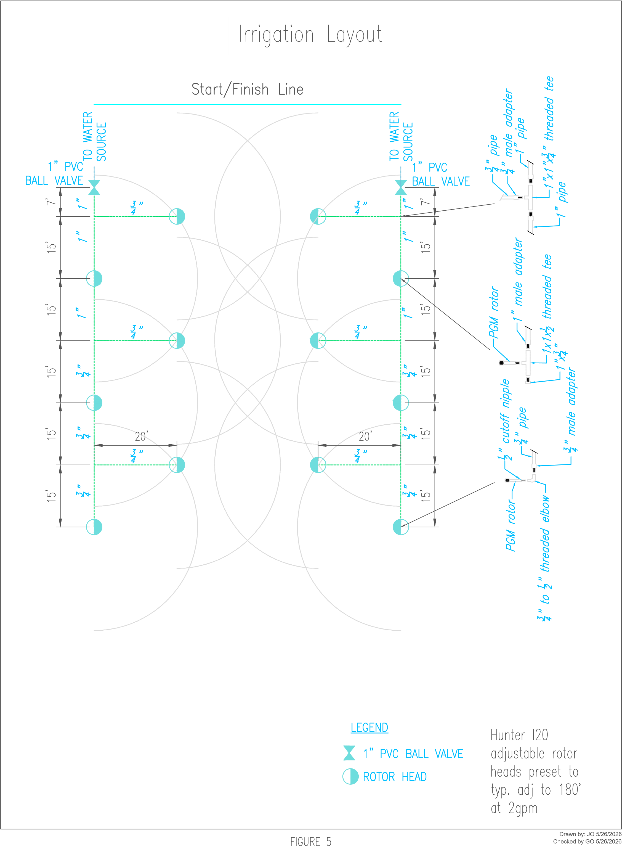
JUDGE’S SCORING FORM

IRRIGATION ASSEMBLY
Contestant 1:
Contestant 2: Agency/Team:

Elapsed time: : : Elapsed time converted into seconds:

Penalties
- Add 10 second penalty for each sprinkler head not facing the right direction.
- Add 10 second penalty for each head that falls to the ground when water is turned on.
- DQ if poor assembly results in major water leak.
- DQ if system does not follow specified layout.
# 10 second penalties: (i.e. 3 penalties = 30 seconds) Disqualification? Yes No

Scoring
- Total elapsed time from start to finish in seconds; add any penalty time to obtain final adjusted time score.
Elapsed time (in seconds)
+ total penalties (in seconds)

Final time (in seconds)
Ranking: (Completed after all contestants have gone.)

Judge’s Signature
Judge’s Signature


TRAPS Maintenance Rodeo
Appendix A – Planning Document

Set-up Supplies (Actual needs may very)
Marking Paint | Traffic Control for event
Measuring tape | Sign Holders/ A- Frames
Results board/ Markers | Maps for participants/ parking | Posted QR codes are recommended for maps/ information
PA System | Laptop with internet connection
Setup/ Check-in Tables/ Tents
Water/ Coolers
First Aid Kits
ATV/ RTV/ Golf Cart

Truck/Trailer
Whistle - 1 | Scoring forms | Suggested # of Judges
Stopwatch - 1 |  | 5
Clip Board - 1
Cones – 56 |  | Approx footprint 130’ x 80’
Tennis Balls - 56 |  | Footprint includes “Safety buffer”
Half-ton Single Cab Truck - 1
Trailer 7’x16’ tandem axle - 1
Wheel chocks - 2 (1 set of 2 connected)

Mower
Whistle - 1 | 60”-72” underbelly Z Mower with chute - 1 | Suggested # of Judges
Stop Watch - 1 | 55 gallon barrels - 3 | 4
Clip Board - 1 | 6’ Picnic Table - 1
Cones - 28+ | PVC Fitting - 4+ | Approx footprint 30’x 85’
Tennis Balls - 32+ |  | Footprint includes “Safety buffer”
Scoring forms

Backhoe
Backhoe - 1+ | Whistle - 1 | Suggested # of Judges
10# kettlebell - 3+ | Stopwatch - 1 | 3
20# kettlebell - 3+ | Clip Board - 1
30# kettlebell - 3+ | Scoresheets
4’x8’ plywood - 2+ |  | Approx footprint 40’ diameter half circle
2’x2’ plywood - 4+ |  | Footprint includes “Safety buffer”
55 gallon drum - 1
55 gallon drum (extra) - 2

Nail Driving
24oz Framing Hammer - 2+ | Whistle - 1 | Suggested # of Judges
20d bright common nails | Stopwatch - 1 | 3
4”x6” pine plank - 2+ | Clip Board - 1
Flak jacket |  | Approx footprint 10’x10’
Face shield - 1+ |  | Footprint includes “Safety buffer”
Nail setting guide - 1+ 3.5” |  | Buffer”
Scoring forms
2 wooden saw horses

Backpack Blower
Backpack Blower - 1+ | Whistle - 1 | Suggested # of Judges
Hearing Protection - 1+ | Stopwatch - 1 | 3
Cones - 8 or Wickets - 4 | Clip Board - 1
Tennis Balls - 2+ | Scoring forms | Approx footprint 85’x 25’
 |  | Footprint includes “Safety buffer”
 |  | Buffer”

Plant/Weed ID
10 ornamentals |  | Number of Judges
5 trees | Stopwatch - 1 | 3
5 weeds | Clip Board - 6+
5 tables
Number Labels 1-20 |  | Secluded area for tables
Pencils |  | Holding area for contestants
Scoring forms |  | Plant area must be “Private”

Irrigation Assembly
See additional sheet | Whistle - 1 | Suggested # of judges
 | Stopwatch - 2 | 3
 | Clip Board - 2
 | Scoring form | Approx footprint 80’x50’
 |  | Must have ability to
 |  | pressurize with water
 |  | Irrigation staff preferred for
 |  | This event

Irrigation Assembly Material List (If space does not allow for 2 lanes, numbers can be reduced in half):

2 - 1” threaded ball valve
2 - 1” pvc pipe 7” length
6 - 1” pvc pipe 15’ length
6 - ¾” pvc pipe 20’ length
4 - ¾” pvc pipe 15’ length
12 - Hunter I20 rotor Heads (preset to 180°)
8 - 1”X1”X ¾” threaded tees
2 - ¾” threaded tee
16 – 1” male adapters (pre-glued to both ends of each piece of 1” pipe)
20 – ¾” male adapters (pre-glued to both ends of each piece of ¾” pipe)
2 – 1”X ¾” threaded reducer
8 – ¾” threaded 90° elbows
12 – ¾” cutoff nipples (add plenty of spares)
2 – Adapter (needed to get from 1” threaded ball valve to water source)
**Needed pipe and fittings to get to water source, dependent on locations

All events:
Best Practice- Have extra supplies (cones, tennis balls, kettlebells, stopwatch, etc.) on hand. Additional Zero Turn, Backpack Blower, and/ or Truck & Trailer must be the same model and size.

(Updated 8/7/2026)

