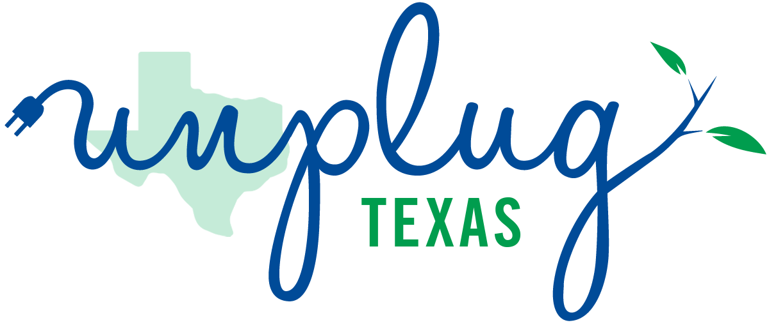
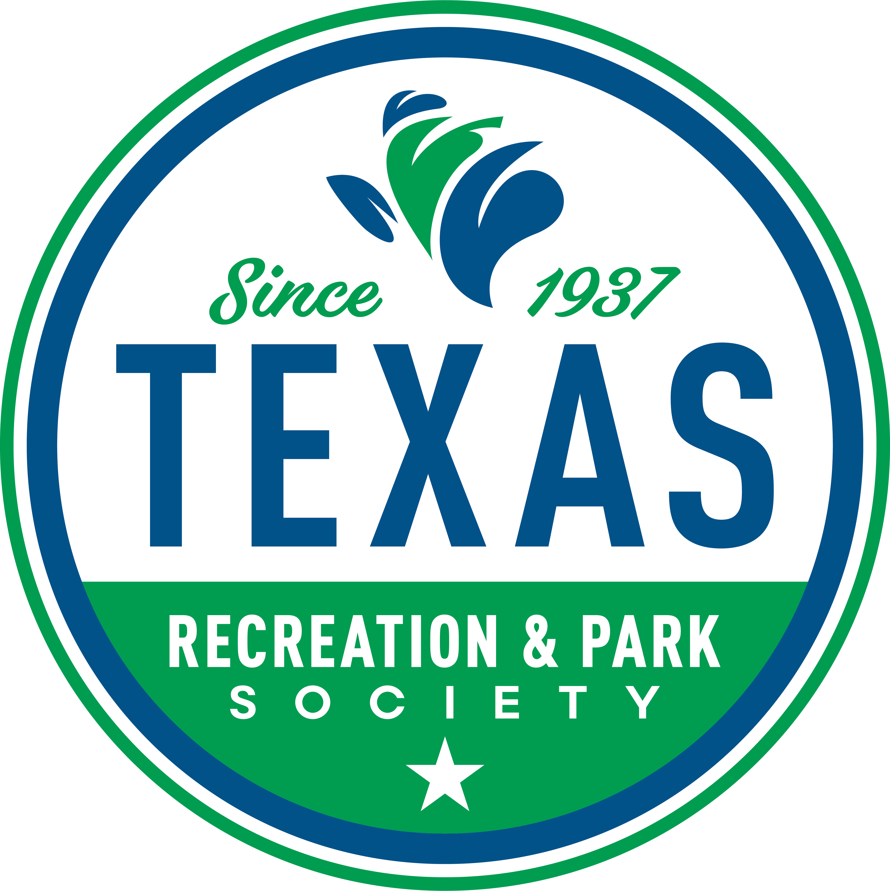

Unplug Texas email templates

OPTION 1:
Subject: Join Us for Unplug Texas Day – October 21, 2025
Dear [Name/Colleague],
I’m reaching out to invite your organization to join the Texas Recreation and Park Society (TRAPS) in celebrating the very first Unplug Texas Day on October 21, 2025.
Unplug Texas Day is a new statewide observance, created when Governor Greg Abbott signed Senate Bill 2232 into law, encouraging Texans to log off, get outdoors, and reconnect with one another through parks and recreation. Inspired by the success of Unplug Illinois, this movement highlights the vital role parks, trails, open spaces, pools, and recreation centers play in supporting health, wellness, and community life.
Here’s how your agency can get involved:
- Host an Event – Plan a program, activity, or event that encourages residents to “unplug and play.”
- Register Your Event – Share your plans with TRAPS so we can amplify your efforts statewide. Agency - Unplug Texas Day 2025
- Take the Pledge – Commit your organization to participate and show how you’re helping Texans unplug. Unplug Texas Day Pledge 2025
Resources to Make it Easy
TRAPS has prepared a full toolkit with logos, sample press releases, social media graphics, and flyers to help you promote your event. Unplug-Texas_Toolkit-2025.2.pdf
This is a powerful opportunity for us to come together and showcase the impact of parks and recreation across Texas. I hope you’ll join me in making the first Unplug Texas Day a success.
Please let me know if you have any questions — and thank you for helping spread the word!
Warmly,
[Your Name]
[Your Title / Organization]
[Your Contact Information]

OPTION 2:
Subject: Celebrate Unplug Texas Day – October 21
Dear [Name],
Join us in celebrating the first Unplug Texas Day on October 21, 2025! This statewide initiative encourages Texans to log off, get outdoors, and enjoy parks, trails, pools, and recreation centers.
How to participate:
- Host an event for your community.
- Register your event with TRAPS so it can be highlighted statewide: Agency - Unplug Texas Day 2025
Let’s come together to show the power of parks and recreation in building healthy, connected communities!
Thanks,
[Your Name]
[Your Title / Organization]

